**Reflections**

**Tibetan Medicine Healing**

**with Dr Deron Ling**

**Doctor of Holistic Medicine**

[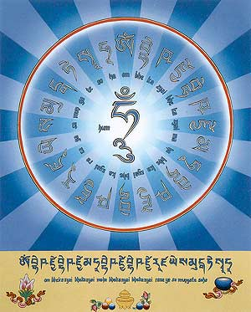](http://www.dharma-haven.org/tibetan/medicine-buddha.htm)

**May 9 – 13, 2018**

***An ancient and profound integration of science and philosophy; Tibetan Medicine is a tradition rich in the practices of maintaining health and alleviating sufferings of both mind and body. It is one of the most comprehensive traditional medical systems in Asia. It has nearly four thousand years of history, ever since Tibetans first invented this unique healing system high on the Tibetan plateau.***

**May 9 (Tues) 7 pm – 9:30 pm Introductory Evening and A Practical Course on the Healing Power of Mantra and Visualisation** In this evening, Dr Ling will share with us the core of integrated healing of body and mind though Tibetan Medicine. The whole of Tibetan medical study can be divided into four parts or subjects: physiology, pathology, diagnosis, and treatment. With this approach one can study the human body and its illnesses, learn to recognize disorders, and develop knowledge and experience of the treatment of illnesses.

By special request, Dr Ling will be sharing **The Healing Power Of Mantra and Visualization** in a practical workshop. Description of the workshop:

Understand how Mantras and Visualisation can have the power to promote peace, wellness, prosperity and love in your life.

[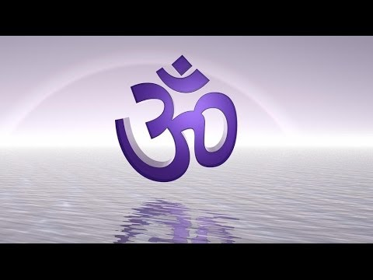](https://www.pinterest.com/pin/108579040991131416/)- what is a Mantra?

- How does a mantra works in healing?

- what is the right way of reciting a mantra to get its full benefits.

- Group practice for the evening a mantra for purifying karmic obstacles.

Mantra is among one of the most ancient science of sound therapy and magic. It is dated back 5000 years even before the Buddha’s time. Mantra is used and practiced in all spirituality and religion of many cultures throughout history and time as chants and incantations.

Anyone can benefit from this science to gain peace, good health, prosperity, longevity, love and happiness as mantras are universal by nature.

One can be from any race or creed to practice mantra therapy.

**Energy exchange for love: HK$200 (money will go to help cancer support)**

**May 11 (Fri) 7:15 pm – 9 pm HK$380**

**Sri Yantra Quantum Healing Meditation**

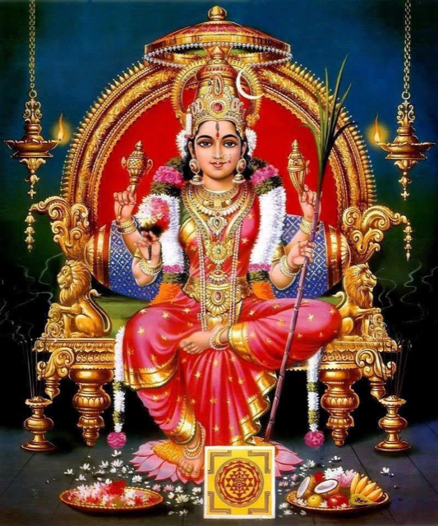

Everyone can practice Sri Yantra Quantum Healing Meditation now... Everyone can experience the grace from all the goddesses now....

Everyone can heal and change their karma now...

In this meditation class, we will do a rare practice with visualization and mantra chanting according to the Sri Vidya tradition and mantra healing

**THE PRACTICE OF SRI YANTRA QUANTUM HEALING MEDITATION –**

Every class we will work on different areas of healing and transformation. Specifically, we will learn  
. **Self Healing   
. Hooking back lost vital essence and life force**

**. Karmic Purification  
. Attract material abundance**

**. Protect from malefic planetary influences**

**. Unblocking our 72,000 energy points and subtle chakras cleansing.**

**Sri yantra quantum healing meditation** is a technology of materialisation (Shrishti Chakra) as well as Dematerialisation (Sanghaar Chakra). It empowers the practitioners with unlimited abundance and thus able to lead a very blissful and content life as he gradually moves towards Self awakening which is the ultimate reality. It promotes a healthy body that is in a constant rejuvenative mode. A mind that is inspired, guided and powerful. Sri Vidya begins where the Quantum physics ends. It's the science of understanding the Microcosm and Macrocosm.

**Sri yantra quantum healing meditation** is the technology of materialisation. When our level of consciousness gets raised the Sri Chakra that residing in us starts vibrating at a very high frequency, thereby starts materialising whatever we want to achieve in life - good health, prosperity, perfect relationship, success, victory and happiness.. the list are endless. A Sri yantra quantum healing meditation practitioner has the powers to achieve and materialise whatever he / she wants in life - like the wish fulfilling gem 'Chintamani' all their wishes and desires get fulfilled.

By the grace of Divine Mother Tripura Sundari; come experience and learn Sri yantra quantum healing meditation from Spiritual coach Deron Ling and achieve complete success endeavour in both your material and spiritual pursuit.

**RSVP is required** [info@reflections.com.hk](mailto:info@reflections.com.hk)

**~ ~ ~ ~ ~ ~ ~**

**May 12 – 13 (Sat & Sun) 10 am – 5:30 pm**

**MEDICINE BUDDHA LAPIS LAZULI LIGHT ENERGY HEALING (SOWA RIGPA) LEVEL ONE**

*for healing one self & Others*

**Guided by Deron Ling (DHM) according to Tibetan Medicine text.**

**Exchange Abundance: HK$3500**

**Early Bird (on or before April 29) HK$3200**

**Bring along a friend and pay HK$3200 each**

According to Yuthok yonten gonpo the founder of traditional Tibetan medicine that to be blessed with perfect health one cannot separate oneself from the spiritual realisation of the True nature of our existence. Health and spirituality always go hand in hand.

Base on the four healing medical Tantra text the Medicine Buddha healing and meditation helps to balance ones inner and outer environment of our body, speech and mind. Thus it helps us to heal ourselves from the cellular level all the way to our consciousness level.

This simple yet powerful practices helps us to improve in our over all mental, physical and spiritual health.

It helps lower blood pressure, clear anxiety and stress, unblock our chakras or energy meridian Centers helping us to improve our vital energy.

Strengthening our immune system and helps to support post and pre cancer therapy and other ailments, it also helps in preventing of all chronic diseases and remove spirits attachment / provocation.

Medicine Buddha Lapis Lazuli Light Energy Healing also helps in the support for the dying and those who have passed on in the intermediate state or Bardo state. It helps the living family members to heal from grief and attachment.

All are welcome to learn and participate in this meritorious knowledge.

**Course outline:**

. Understand the root cause of all physical, mental/emotional and spiritual diseases of our body, mind and spirit according to Yuthok ‘s Heart Essence Tantra.

. Understanding and how to develop  true compassion and loving kindness to all sentient beings as a good spiritual healer to benefit oneself and benefit others.

. Learn how to create ultimate protection against internal and external psychic Attack from humans and other dimensional beings.

. Developing your power of attraction and attractiveness to create good friendship and meeting with good mentors in your daily life.

. Learn the Tantric secrets to manifest your dreams and remove poverty consciousness.

. Healing of different diseases at different levels of our body, mind and spirit.

. Clear away spirit provocation attachment and diseases caused by harmful spirits.

. Purification of unwholesome karma and increasing wholesome karma that will benefit us and our love ones. Understand why healing don’t take place and why prayers are not answered.

. Healing ourselves from obstacles and life challenges caused by our karmic debtors human or non human.

. Activating and strengthening all our 72,000 nadis and balancing our chakras. Thus strengthening our immune system and lose weight in a natural way.

All lessons are in bilingual English/Chinese and some Cantonese.

**NOTE**

There are altogether Three Levels for the MEDICINE BUDDHA LAPIS LAZULI LIGHT HEALING.

Practice manual will be given on the day of the workshop. Only upon completion of all three levels will the students receive a practitioner letter of authentication under the Saraswati lineage of HH Swami Shantananda from Dr Deron Ling(DHM).

**May 10 – 11 PRIVATE MEDICAL MANTRA HEALING CLINIC**

**Energy Exchange : HK1200 1.5 hr**

Tibetan and Ayuvedic Mantra Healing (TMH) is a powerful form of healing which utilises the energy of pure vibration - Sound - to heal subtle energetic disturbance. In this way, we can treat the root cause of disorders and diseases, instead of simply treating the symptoms.

The mantras prescribed here arise out of the ancient Tibetan and Ayurvedic medical and spiritual traditions. It is based upon the philosophy of Interdependent Origination of all Phenomena.

They are non invasive to use, profoundly effective, and are immediately accessible to everybody – regardless of age, gender, ethnic or spiritual background.

TMH can be used as a treatment on its own, or in conjunction with other treatment modalities. It is reputed to have profound effects in the treatment of chronic disease.

There are literally hundreds of different Mantras for Healing. Some mantras are for specific problems, such as:

Diarrhoea

Vomiting

Constipation

Viruses

Influenza

Infection

Pimples

Broken Bones

Childbirth

Bleeding from an open wound

Cancers and Tumours, etc.

There are also Mantras to cover more generalised conditions, for example:

Disorders of the Solid Organs such as the Heart, Lungs, Liver, Spleen, Kidneys;

Disorders of the Hollow Organs such as the Gall Bladder, Stomach or Colon;

Disorders of the Senses such as Sight, Hearing;

or to alleviate Pain.

There are Mantras to rebalance the 3 Humours (Wind, Bile and Phlegm). In Tibetan and Ayuvedic Medicine, the 3 Humours are considered to be the 3 vital energies in the body; disease manifests when the 3 Humours become imbalanced.

There are also Mantras for "One Hundred Diseases". Tantric Medicine speaks of all diseases as being variations of different basic energy disturbances. These Mantras have the ability to heal any sort of problem; they are very effective for illnesses which are complex, or where the cause of the illness may be unknown

Treatment includes checking of body elements (Humour), consultation to decide the different types of Mantras and precise methods for healing.

At the end of treatment a specially prescribed mantra water will be dispensed and some very useful instructions on how to use the water for healing will be advised.

**About Deron Ling (D.H.M.)**

Deron Ling is a Doctor of Holistic Medicine certified by the Faculty of Medical Studies Medicina Alternative Institute, affiliated to The Open International University for Complementary Medicine (ALMA ATA 1962), certificate approved by the United States Licensing Authority.

Deron Ling at the age of 26 met his guru His Holiness Shantananda Saraswathi and Was given the name Dharmadasa Saraswathi Under the Saraswathi linage of sages.

Under His Holiness guidance Deron was initiated into the most secret and profound Sri Vidya. Seeing his potential His Holiness sent him to upgrade his knowledge and study under many great masters from various traditions. Deron furthered his studies in tantric Buddhism and Taoism. Upon completion of his studies Deron came back to His Holiness and was given the task to travel round America and Asia to teach meditation therapy and spreading the teachings of His Holiness on self healing and the dharma of Marici essential heart tantra or it's called 'The sun rays that eliminates the darkness of suffering' tantra.

He is also a noted teacher in meditation therapy, Medicine Buddha reiki, quantum sound therapy and has taught many students in Asia and the United States. He is closely affiliated to the ‘Path of Light Center’ USA California and has conducted many healing modalities there. Garuda Grace Light, a healing modality base on the principles of Ayurveda, is one of the many courses he had conducted there. He is also the creator of ‘Only Love can Heal’, a holistic healing workshop specially for women. He also participated as a guest speaker in the World Congress of Holistic Medicine held in Chiang Mai Thailand on April 2004.

Also a practitioner of the Ancient Iching, Deron has va­st experience in the field of Vedic Astrology and geomancy, bringing the ancient wisdom to practical application. He has been advisor to people from all walks of life from government officials, businessmen to students, etc

He also travels extensively giving lectures and talks to groups, office and Spiritual Institutes. His personal philosophy is to guide students and clients to develop self responsibility and self love to heal at a holistic level of body mind and soul.

**To join the introductory evening, Sri yantra quantum healing meditation, 2-day MEDICINE BUDDHA LAPIS LAZULI LIGHT ENERGY HEALING (SOWA RIGPA) LEVEL ONE workshop and / or book a private session with Dr Deron Ling, please call Reflections on 2504 1333 Whatsapp Ruby T Ong@9401 4713.**

