By special request, Julie is conducting an evening of Tarot workshop …

Reflections
Step into the Magical World
of the Tarot!
with Julie Cook
International Renowned Psychic Medium

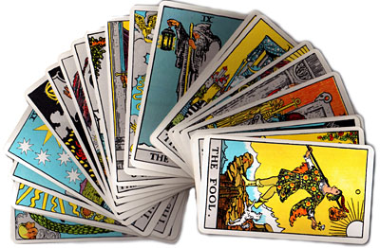
May 24, 2018 (Thurs) 7 pm – 10 pm

Exchange Abundance: HK$888

The Tarot has been used for centuries both as a tool of divination and as a meditation and
visualisation aid.

In this innovative workshop you will gain the basic skills needed to interpret any combination of cards in a variety of useful spreads, from simple one and three card daily readings to creating your own spreads for specific questions.

Over many years of teaching and working with the Tarot both at home and abroad, Julie has developed her method of teaching which includes little 'memory triggers' with easy ways to retain the meanings of the cards.

Whatever your level of experience from beginner to those who already have some knowledge of the cards this workshop will deepen your understanding and you'll have a lot of fun learning!

What you will learn:

- The four Tarot suits and elements that define them
- The difference between the Minor and Major Arcana
- The Numerology of the Minor Arcana
- Understanding of the Major Arcana and Tarot journey
- Basic Tarot spreads and how to create your own
- You will then be equipped to practice, learn and develop further in your own time.

**Participants are encouraged to bring their own tarot cards if they have any.

To join the Tarot workshop with Julie, please call Reflections on 2504 1333 and / or whatsapp Ruby T Ong 9401 4713.

