Reflections
Living Light Energy (Sekhem)
生命之光能量--古埃及能量療癒法
LEVEL 2

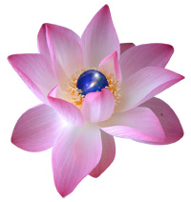
July 7 – 8 , 2018 (Sat & Sun) 10: am – 5 pm

The focus of the Level Two workshop is to deepen the underlying philosophy of the Living Light Energy and its use in your everyday life and to strengthen and advance the basic healing techniques. To deepen your own empowerment, personal development and remembering of who you truly are.

Participants will be attuned to this level individually and the following will be covered:
- Six symbols and their meanings and use
- How to send the Living Light Energy by distance and absent healing techniques
- Ways of energetically healing and empowering relationships and situations
- Techniques for releasing mental, emotional and physical blocks and imbalances
- Using affirmations with Sekhem

Exchange abundance: HK$3,900

To participate in the Living Light Energy (Sekhem) – Level 2 with Master / Teacher Ruby T. Ong, please contact Reflections on 2504 1333.

Please call 2504 1333 to schedule a private 40-minute attunement session before the class. The Living Light Energy Initiations are gifted in a healing environment, on a one to one basis.

Whatsapp Ruby T Ong 9401 4713

*Students who had finished different levels of the Living Light Energy are welcome to join the classes for revision.

Profile
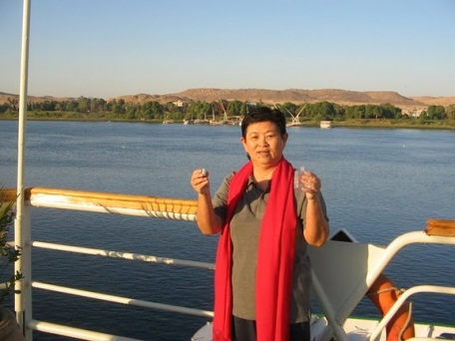
Ruby T. Ong is an experienced healer and caring teacher who takes pride in empowering the individual to maximize their own potential. She believes that, with self-empowerment, people will be more aware that they have a response-ability to live their life with their vision of faith. She is also well trained in different levels of Pranic Healing and other healing modalities. Her personal public relations consultancy M V Reach Communications is a major organizer of holistic events in Hong Kong.

To date, Ruby is always on the road, she has been traveling extensively to major cities in China, including: Beijing, Shanghai, Qingdao, Shenyang, to name a few. Recently she has been invited to conduct Sekhem workshops in Netherlands and Denmark.

