Reflections
PRIVATE SESSIONS
with Jacqui Gilbert
JAC Metaphysical Teacher, Healer and Channel
GILBE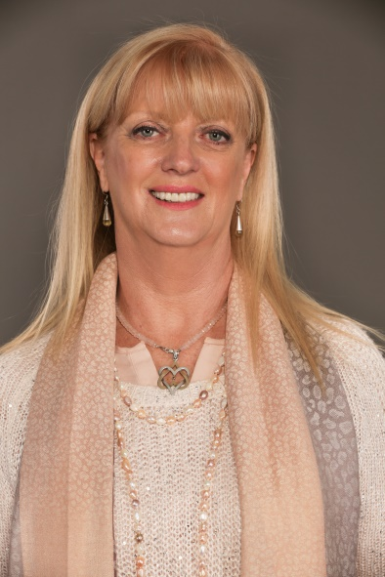RT
August 16 - 20, 2018

PRIVATE SESSIONS HK$1500 for 1-hr session
READING AND CHANNELING
Private session will be communications by Osiris. There may be cards reading and channeling.

Who is Osiris?
Osiris has also been known as Apis-Osiris and as Serapis or Sarapis in Ancient Greece. He is an extension of the consciousness of Enki or Enki Ptah and is one of the Trinity – which is made up of Osiris, Isis and Horus. Although he has lived many different lifetimes on Earth and we would correctly call him by numerous different names, the glorious Light Being currently speaks to us as Osiris.

ABOUT JACQUI GILBERT:
Based in South Africa, Jacqui has enjoyed an international following as an inspirational facilitator of personal growth and transformative workshops for many years. She has worked extensively around the world using techniques of healing, channeling, meditation and energy processes.

As the founder of the Transformation Development Centre and a powerful psychic, healer and channel of Spirit Beings, Jacqui supports people on their journey of personal growth and healing in a safe environment of unconditional love, and joy. She presents specialized workshops, offers private readings, channelings and healings, accompanies guided tours to sacred sites around the world and has co-authored various books, sharing her gift with love and light to all.

A brilliant clairvoyant and psychic, Jacqui is returning to Hong Kong upon special request from clients. She continues to offer her regular individual sessions including tarot/rune readings, transformational healing sessions and channelings.

CONTACT Reflections for bookings @ info@reflections.com.hk Whatsapp Ruby T Ong @9401 4713

