Reflections
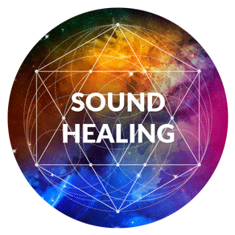
August 31, 2018 (Friday)

INDIGENOUS SOUND HEALING

Concert of Mystical Instruments That Induce Profound Relaxation & Inner Quiet

with Gabriel Landolfi
Sound Massage Therapist

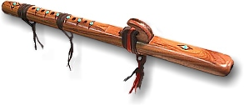
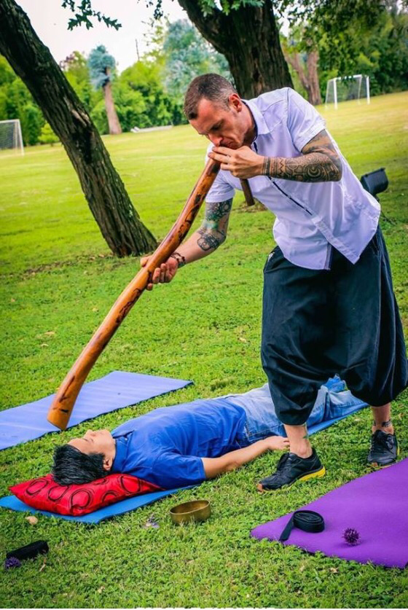
~ ~ ~ ~

Immersed with the Paiste 32” Symphonic Gong sound …
with Ruby T Ong
Gong Player

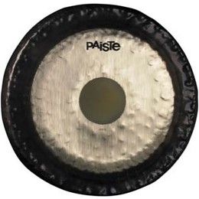

~ ~ ~ ~ ~
Inner Sound Healing of Acutonics Tuning Forks
Chiu Lai Kuen
Acutonics® Sound Healing Therapist

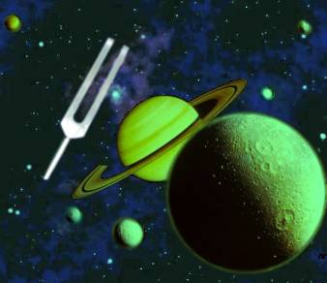

Come join us for an amazing journey of sacred sound, relaxation and meditation

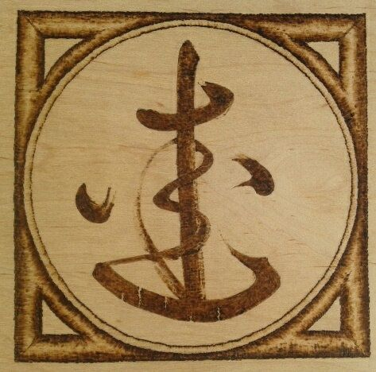
Experience the different powerful therapeutic instruments such as didgeridoo, chimes, singing bowls, tabla, cymbals, native American Indian flute …

Allow this therapeutic healing art to help you resolve physical, emotional and spiritual dissonance, balance and harmonize human energy field, promote well-being

Our evening will start off with a soft, pure penetrating sound waves of the healing gong and the tuning forks to connect you to the Universal Consciousness … followed by the sacred sounds of the different indigenous instruments … ending with a Guided Metta Meditation

Time: 7:00 pm …participants arrive to set up yoga mat, cushion
7:30 pm Concert starts
9:15 pm Concert and meditation end

Venue: The Dance Academics
1/F United Bldg
449 Hennessy Road, Causeway Bay (beside Public Bank, near
Gooseneck Bridge 鵝頸橋 )
Exchange Abundance: HK$350

***Participants are requested to arrive 30 minutes before the session. Late comers will not be entertained.
***For your comfort, please bring yoga mat, blanket, cushion and plenty of water to drink.
Chairs will be available for those who prefer to sit.
Pre-registration is recommended as this event tends to fill! Please call Reflections on 2504 1333. Whatsapp Ruby T Ong 9401 4713 Kitty Lam 9276 2461

