**Reflections**

**LIVING LIGHT ENERGY (Sekhem)**

**Foundation Level**

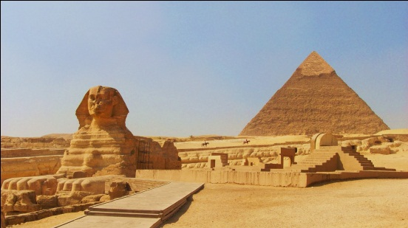 **with Master / Teacher RUBY  T   ONG**

**Sept 1 - 2, 2018 (Sat & Sun) 10 am – 5:30 pm**

***Living Light Energy*** is an advanced energy healing system. Like Reiki, it is a channelled energy with a higher vibrational level. Both Reiki and Seichim are encompassed within the greater healing power of ***Living Light Energy f***or it is considered to be the origin of all hands-on healing systems, as it was taught in the very early temples of ancient Egypt, Lemuria and Atlantis.

***Living Light Energy*** works on all the physical, mental, emotional and subtle spiritual bodies at the same time. There is completeness to ***Living Light Energy*** that goes way beyond other systems. It works at the soul level. Because of its power, thought forms and intention activate it consciously. Also the energy can be directed, its intensity controlled and varied at will.

Learn this subtle yet powerful energy where focus is on empowering the individual to develop their own path, to promote oneness and self-healing, healing of others and healing any other problem in one’s life.

Learn to master the flow of energy. This is a powerful ancient Egyptian vibrational healing modality. Topics include: sensing energy, understanding illness and healing, cleansing the auric field, channeling, moving and directing the energy flow, creating a sacred space and a safe environment, creating forgiveness, techniques of self healing and protection. Activities include meditation, interactive discussion and experiential hands-on healing techniques.

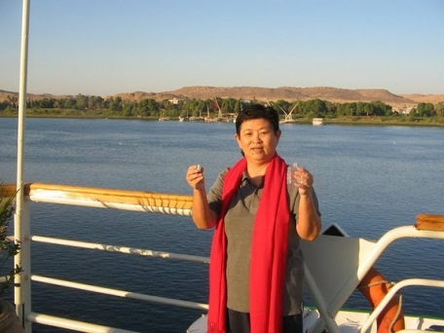**Ruby T. Ong** is an experienced healer and caring teacher who takes pride in empowering the individual to maximize their own potential. She believes that, with self-empowerment, people will be more aware that they have a response-ability to live their life with their vision of faith. She is also well trained in different levels of Pranic Healing. Her personal public relations consultancy M V Reach Communications is a major organizer of holistic events in Hong Kong.

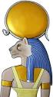 **Please call 2504 1333 to schedule a private 40-minute attunement session before the class. The Living Light Energy Initiations are gifted in a healing environment, on a one to one basis.**

**No previous healing knowledge or experience is required. Course materials are in English. Workshop can be conducted in English, Cantonese and Mandarin.**

**Exchange Abundance: HK$2800 (includes a 40-minute individual attunement / healing session)**

**LIVING LIGHT ENERGY (SEKHEM) HEALING SESSIONS 1 – 1.5 hr session (including *Reflections* Counselling + Sekhem Healing with Selenite wand) HK$1500**

**What to Expect**

Everyone arises from a session feeling very relaxed and with a deep sense of well being. The person receives exactly what is appropriate for them because it is the energy working in concert with your Spirit that creates the healing.

You receive the healing while lying comfortably and fully clothed on a massage table. The practitioner channels the energy by gently placing their hands in different locations on the body or slightly above the body.

Healing is not curing in the traditional sense and everyone experiences something different when working with these energies.

For some it offers immediate relief from physical pain, calm to agitated mind and emotions, or a different way of seeing our problems. For others the healing is more subtle where in the days and weeks following, you have a realization of transformation inside yourself as well as in your life. Gentle, yet powerful and significant shifts in awareness along with new revelations occur.

As the energies refill and balance you, you connect more fully to your Spirit and experience the healing happening on all levels - physical, mental, emotional and spiritual. Before doors appeared closed and locked. Now - new choices are possible and effortless and you are forever changed.

|  |
| --- |
| Individual sessions generally run 1 to 1 ½ hours and begin with a time to share and discuss what is going on in your life. Some people choose to come weekly when they are feeling stuck, or in transition. Others come monthly for a "tune-up." One session can also be sufficient to reveal what is needed next in your life.Benefits of Sekhem |
| Sekhem Healing accelerates the body's natural ability to heal itself on all levels and at the same time promotes feelings of deep relaxation and well-being.   * Relieves physical pain * Reduces and releases stress and tension * Lessens feelings of anxiety, fear and depression * Promotes feelings of calmness and clarity * Strengthens the immune system * Assists and opens us to achieving our highest potential * Promotes and strengthens intuition and creativity * Supports during the grieving process and life transitions * Releases blockages at all levels * Balances our physical, emotional, mental & spiritual bodies   **To join the Living Light Energy (Sekhem) Foundation Level workshop and / or book a private session, please call Reflections on 2504 1333**  **Whatsapp Ruby T Ong 9401 4713** |