Reflections
PSYCHIC INVESTIGATION
with ANN TREHERNE
Chair, The Sir Arthur Connan Doyle Centre, Scotland.

October 25 – 28, 2018

~ ~ ~ ~ ~ ~ ~

Oct 25 (Thurs) 7:30 pm – 9 pm HK$333

Ann Treherne : Her Amazing Story talk

FROM CEO TO PSYCHIC INVESTIGATOR

Venue: Room 203 - 2/F Duke of Windsor Social Service Bldg
15 Hennessy Road, Wanchai, Hong Kong

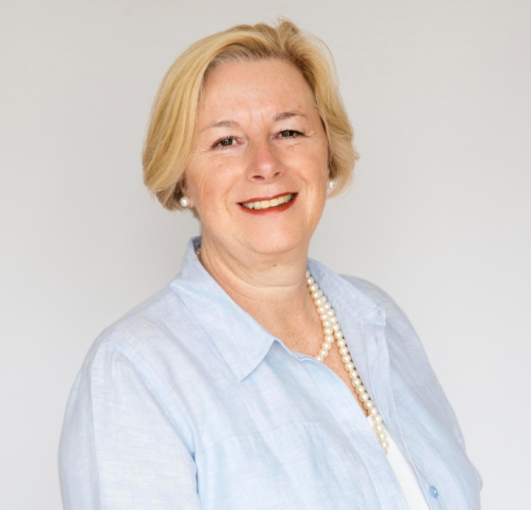
Ann Treherne:
* Chair, The Sir Arthur Conan Doyle Centre
*Member, Society for Psychical Research, London
*Renowned Psychic Investigator
*Member, Scottish Society for Psychic Research
* Member, Edinburgh College of Parapsychology.
* Biofield Energy Assessor and photographer
*Aura Camera Operative & Consultant

Ann Treherne comes from a corporate background in banking and finance. Back in 1996, she left the corporate world, having encountered premonitions which she states as being ‘dramatic and traumatic’. This, was her ‘wake-up call’ which caused her to seek out answers and ultimately to give up her job to become a Psychic Investigator and to focus on her psychic and mediumistic development.

Now a Medium in her own right, Ann has worked with some of the best-known names in the industry, including James Van Praagh, Tony Stockwell and of course, Gordon Smith. Although she has often worked abroad, Ann comes from Edinburgh, the birthplace and hometown of Arthur Conan Doyle and is Chair of The Centre which bears his name, where she hosts events from only the very best mediums worldwide.
Like Arthur, Ann is a Psychic Investigator and long-standing member of The Scottish Society for Psychical Research. As well as tutoring in Meditation, Psychic and Mediumistic Development, she also trains Psychic Investigators and Researchers. In her no nonsense approach, she advocates investigation via scientific and analytic means and believes that some of the psychic phenomena that has been witnessed in more recent years, if subject to testimony by independent witnesses, can provide evidence of the continuance of the human personality after death.

More recently Ann has developed her area of research into ‘the Biofield’, commonly referred to as ‘the Aura’. “Every living thing omits an electro-magnetic field”, says Ann, “Modern technology, is now able to reveal normally ‘invisible’ light patterns. By filtering gradations and patterns of light not normally visible to the human eye, this technology allows us to see the subtle energy around us”. Indeed during her talk Ann will be showing some amazing footage of spirit contact captured by this aura film camera.

Ann is currently writing a book about her experiences and when not directing operations at The Sir Arthur Conan Doyle Centre, she travels nationally and internationally giving talks and running training courses on Mediumship, Psychic Investigations, Aura Readings and Workshops, and of course, on Arthur Conan Doyle.

Join her on Oct 25 (Thurs) at the our Central Venue to hear Ann talk about her amazing story from CEO to Psychic Investigator; about those traumatic premonitions that eventually led to her giving up her job and about this new technology that allows us to see the energies that up until now, only psychics and mediums can experience.

Transport Information
- Take the exit A2 of the MTR Wan Chai Station, turn right and walk along Henessey Road for around 10 minutes.
- Take Bus No. 1, 37B, 75, 90 or 97 (get off at Asian House Stop); OR take Bus No. 1, 5B, 5X, 11, 23, 25, 26, 37A, 40, 75, 90 or 97 (get off at Anton Street Stop)
~ ~ ~ ~ ~ ~

Oct 26 (Fri) 7:30 pm – 9:00 pm HK$550
PSYCHIC INVESTIGATION
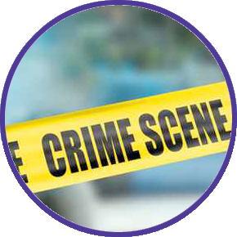

Venue: Room 203 - 2/F Duke of Windsor Social Service Bldg
15 Hennessy Road, Wanchai, Hong Kong

Join Ann Treherne, a Psychic Investigator, as she takes you through the process of solving cases with nothing but psychic ability. Ann will present case studies and take you through the collection of evidence mediumistically and psychically using different tools in the field of intuitive investigation.

During the evening, she will be exploring the myths and realities of psychic investigations and reviewing the types of phenomena that can, and have been witnessed. She will give a brief outline of how psychic investigations should be carried out, and will also be detailing some case studies – from helping the police search for a body to the airline pilot who met and shook hands with his fellow pilot and later found that his colleague was already dead at the time! To her own story of Arthur Conan Doyle communicating from beyond the grave. Ultimately Ann says, “By careful investigation and searching testimony from credible witnesses, there is evidence of life after death”.
~ ~ ~ ~ ~

Oct 27-28 (Sat - Sun) 10 am – 5 pm
INTERACTIVE WORKSHOP
AN INVESTIGATION INTO THE UNSEEN WORLD
with Ann Treherne and Dr Susan Jamieson

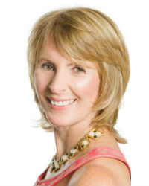

JOIN US FOR AN EXCITING WEEKEND AT REFLECTIONS WITH PSYCHIC INVESTIGATOR, ANN TREHERNE AND DR SUSAN JAMIESON AS THEY INVESTIGATE THE UNSEEN WORLD OF LIGHT AND THE BIOFIELD.

A WORKSHOP OF EXERCISES AND EXPERIMENTS WORKING IN THE ETHERIC FIELD WITH COLOUR ENERGY, HEALING ENERGY AND ALTERED STATES OF CONCIOUSNESS.

THIS IS A CHANCE FOR OUR STUDENTS TO NOT ONLY FEEL THE POWER OF SPIRIT BUT MAYBE EVEN SEE IT LIVE IN FULL TECHNICOLOUR!

Join Psychic Investigator, International Speaker and Tutor, Ann Treherne from Edinburgh, Scotland together with Dr Susan Jamieson, doctor, international speaker, author and Light-Worker as they investigate the power of your aura; the healing power of colour; how altered states of consciousness allow us to interact with our own light body and those in the etheric.
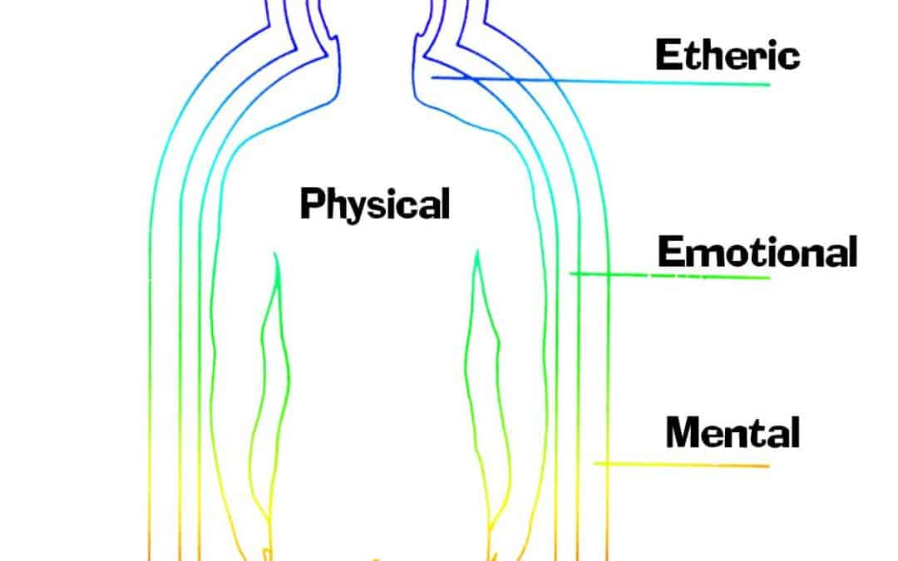
Using new technology, never before seen in Hong Kong, Ann has captured live film footage of spirit contact with a student as it took place at an earlier workshop. She will also show photographic evidence of healing energy being transferred from healer to recipient; and what appears to be a spirit entity appearing on stage with the medium during a demonstration of mediumship.

This is an interactive workshop where students will experiment with these modalities whilst being photographed and filmed for computer analysis using this new technology. Students will then be able to assess and review the footage as a group to consider the changes that have occurred.
Students will get the opportunity to see this footage first hand and through a series of experiments, be filmed and photographed themselves as they experience different forms of energy and assess what changes appear in their own auric field as they work. (Examples below).

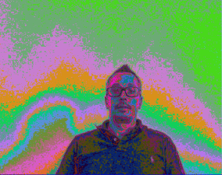
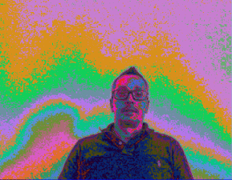
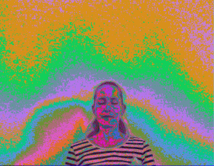
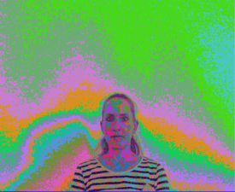
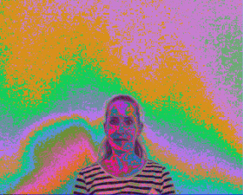

Ann says, ’The technology serves as a tool to help students gain a visual perspective on what’s happening in their aura, but the real goal of is to make students more aware of the power of the etheric, how they can access it for their own benefit and that of others, in the form of healing, communication and personal enlightenment. Come and, ‘Feel the power of the spirit’ .

Profile of Dr Susan Jamieson MBChB MRCGP DRCOG MACNE
Dr Susan Jamieson is a leader in the field of mind-body-spirit, having huge experience both as a medical doctor and also a world specialist in ‘light’ - both the science of light and the spiritual aspect. The light of our DNA and biology; the light of ‘the other side’, evidence form hospice workers, neurologists and medical experts. She has a unique ability to induce an experience of light in others. This is the science of enlightenment!

www.lightdoctor.net
www.drsusanjamieson.com

Note: By attending this workshop students agree to their image being taken both in film and in photographic format and that those images remain the property of Ann Treherne. Students waive all rights to their images and agree that these may be used for promotional purposes in the future.

All attendees at the workshop will receive an Individual photo of their aura, by email.

Venue: Reflections Resource Center
13/F Unit B Suen Yue Bldg
48 Bonham Strand West
Sheung Wan, Hong Kong

Exchange Abundance: HK$2800
Bring along a friend and pay HK$2500 / person

To join the Introductory talk, Psychic Investigation and / or the 2-day Workshop, please call Reflections on 2504 1333. Whatsapp Ruby T Ong 9401 4713

