Reflections
SARCOPHAGUS MEDITATION
fACILITATOR: rUBY t oNG
Sekhem Master / Teacher

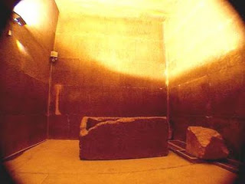

February 9, 2019 (Sat) 3 pm – 4:30 pm

Inside the great pyramid of Giza in the Kings Chamber lies a granite sarcophagus. It is believed the granite sarcophagus was part of an initiation process to develop higher consciousness, through meditation whilst lying within the sarcophagus.
In this meditation, you will be guided to lie down in the sarcophagus to receive an extraordinary powerful ascension attunement to help you awaken to the full remembrance of your true identity. The initiation ceremony is not simply a matter of facilitating individual process of spiritual awakening. In a carefully orchestrated way, the initiation will enhance your ascension consiounessness, enabling you to retrieve your multi-diverse gifts and talents so that you can assist the Mother Earth and planetary ascension in your own way.

After the meditation, you are encouraged to contemplate on how you might take advantage of this seeding of ascension consciousness in your daily life. As you are aware that you have access to great divine assistance each day, you now can play a more effective role in the Divine plan.

Exchange Abundance: HK$222

To join this afternoon meditation, please call Reflections on 2504 1333. Whatsapp Ruby T Ong 9401 4713.

