Reflections

Consult with David Taylor
THE TAROT MASTER WHO NEEDS NO PROMPTS

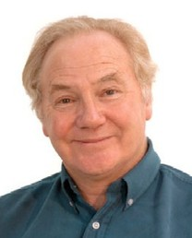
July 11 - 13, 2019

Prepare yourself for what you'll encounter in your love, career, business and relationship life through renowned psychic and tarot reader David Taylor from the UK. David will tell you about your present and your future and guide you intuitively through your life situations.

PRIVATE CONSULTATIONS HK$1400 for 50-min session
Personal Readings
David is acknowledged to be one of the leading psychics in UK, and for many years has been helping people throughout the world with his predictions, words and guidance.
His readings are uncannily accurate and straight to the point and he needs no prompting, affirmations or information from his clients. David's aim is to help people overcome life's difficulties and guide his clients to achieve what they are fully capable of achieving, helping them to become the best they can be.
Business / Career Readings
As well as personal readings David offers a specialized reading for his business clients. Focusing solely on the business/career environment he is able to look in detail at the trends and opportunities around the client in their day-to-day work environment and also the wider financial, political and social factors that may potentially have an influence on their business/career and financial progression. This consultation is designed to help the clients' business prospect and David will require information ( in confidence ) about the business, trends and personalities involved.
Spiritual Identity Consultation
David has been guided to teach a technique for uncovering each individual's spiritual characteristics. Each of us has, in addition to our human personality, a unique spiritual identity. By using the information, channelled to him David has developed a reading using Numerology and Tarot, which reveals the essence of each person's spiritual being. This information helps to explain much of our human behaviour and highlights previously unrecognised strengths that we can call on to help us in our journey through life as well as to reach our goal of enlightenment.

David is immensely popular and appointments get snapped up, so be sure to book your personal reading with him early!
~ ~ ~ ~ ~ ~

BASIC TAROT WORKSHOP
July 13 (Sat) afternoon 2 pm – 6 pm

Exchange Abundance: HK$1500

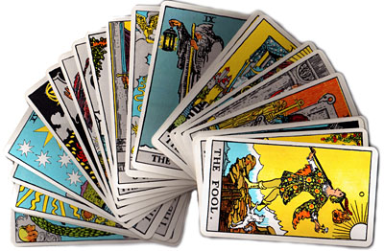
The Tarot Workshop is designed to give the student a working knowledge so that at the end of the session they are able to conduct readings, and with further practice will become adept. It will interest both those who wish to learn a new skill that could benefit others and also those that just have an interest in furthering their own spiritual journey.
This 4 hour workshop takes the student through the meanings of the Tarot, using the cards own images to give an easy, but very comprehensive, way to understand and know them. This does not require learning the written meanings of the cards but simply understanding the images portrayed on them. I have found that over the years I have run this workshop, the end result is that students have a good working knowledge of the Tarot.
There will be time to practice during the workshop and also other aspects on readings can be taught.
Rider-Waite cards are used for instruction and if students do not have their own I have some practice decks that can be used. A course book is supplied with the card meanings, spreads used and some Numerological and Astrological information.
The course is designed in a way that no previous knowledge of the Tarot is required.
A certificate is also presented to the successful students.

About David
David is acknowledged as one of the leading psychics in the UK, and for over 24 years been helping people throughout the world with his predictions and guidance. His aim is to help people overcome life’s difficulties whether they are emotional, career, financial or spiritual and guide his clients to achieve what they are fully capable of achieving, and so helping them become the best they can be.
Born into a family of natural clairvoyants and psychics, David began to take an interest in and study Tarot in 1987 and very soon found that it was a very natural progression from that which had already been discovered in his own spiritual journey.

A natural and gifted clairvoyant, David Taylor is highly intuitive and incredibly detailed in his readings. He utilises a unique combination of Tarot, Astrology and Numerology and is uncannily accurate and straight to the point. He needs no prompting, affirmations or information from you.

In recent years however he has found that although he still uses elements of the Tarot, Numerology and Astrology his readings have become an intuitive process allowing him to channel information directly from the spiritual level.

To book a private session with David Taylor, or join the Tarot workshop, please call Reflections on 2504 1333. Whatsapp: Ruby T Ong 9401 4713

